**Refer eb-get-cont-contacts-service**

1. pom.xml

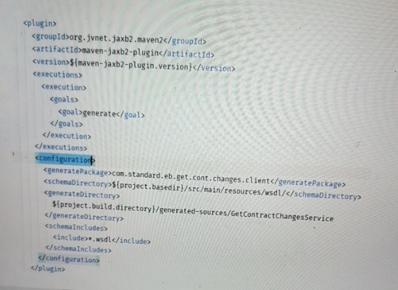

1. wsdl change for service url

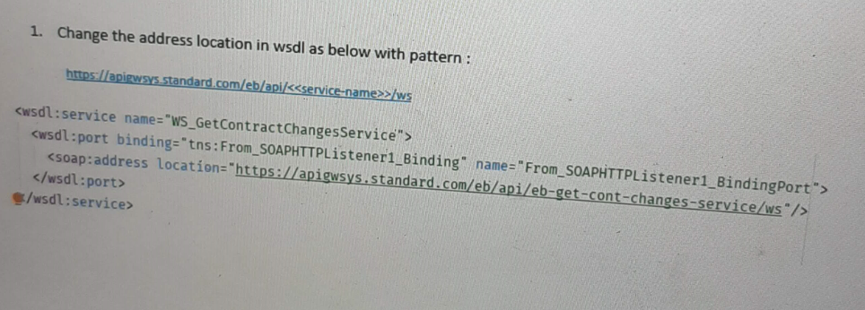

1. wsdl location

<http://localhost:8030/eb/api/eb-get-cont-changes-service/ws>

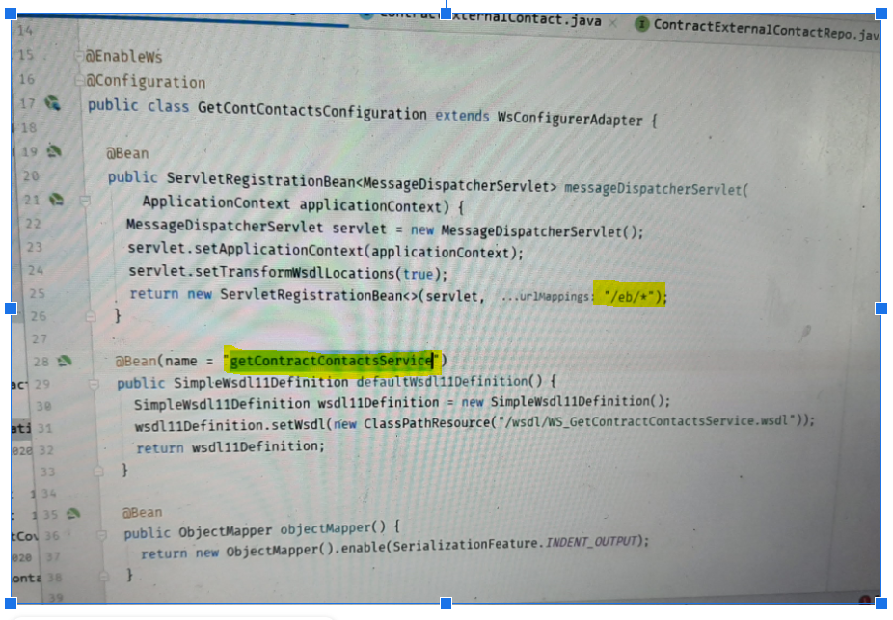

1. Hit the service from SOAP UI

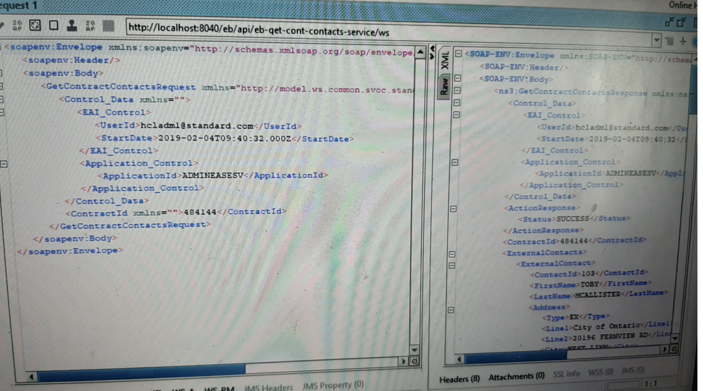

Endpoint class

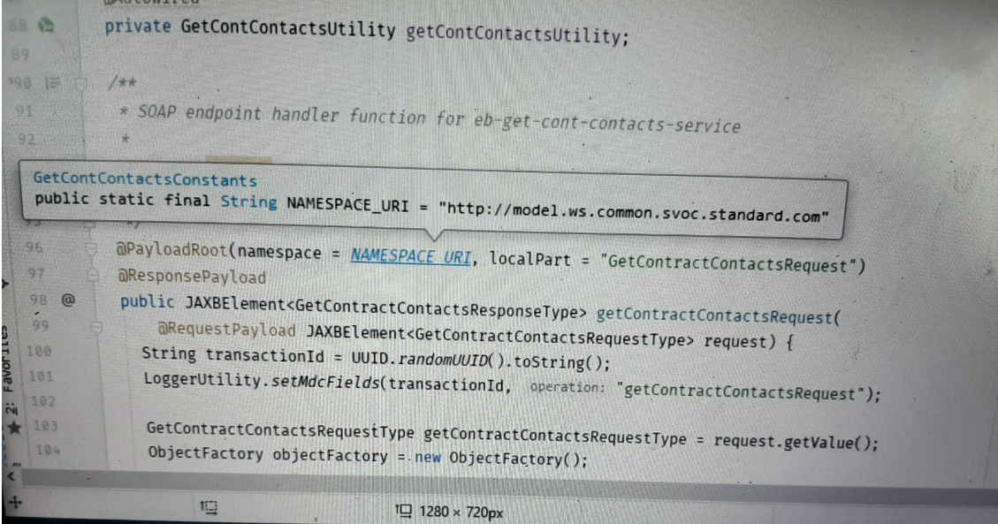

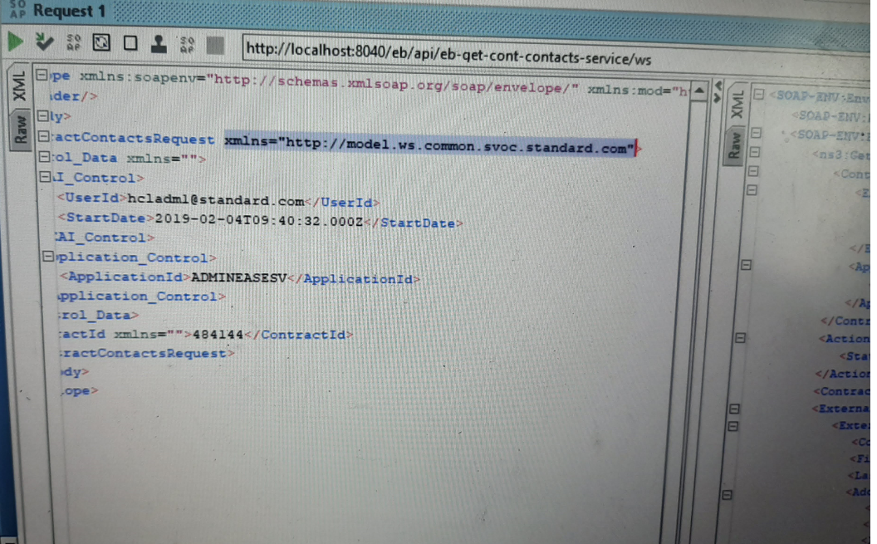

Refer SpringBootSOAP, SpringBootSOAPClient

SpringBoot + SOAP

pom.xml

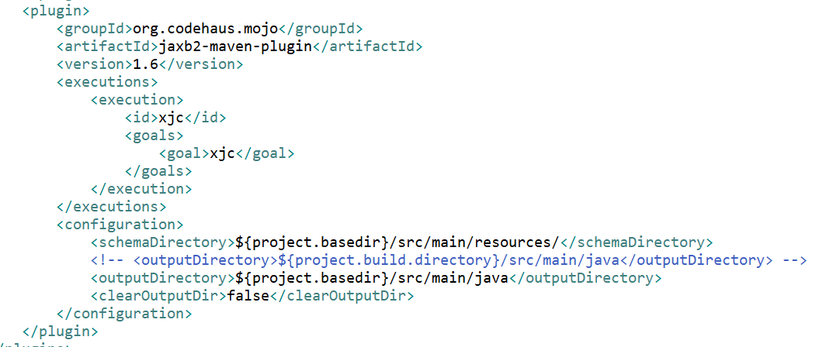

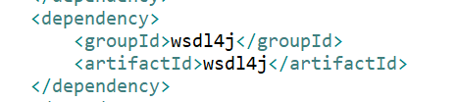

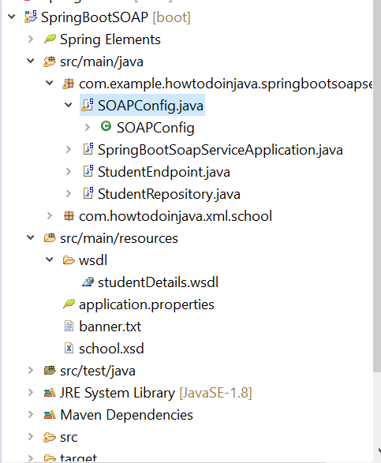

SOAPConfig.java

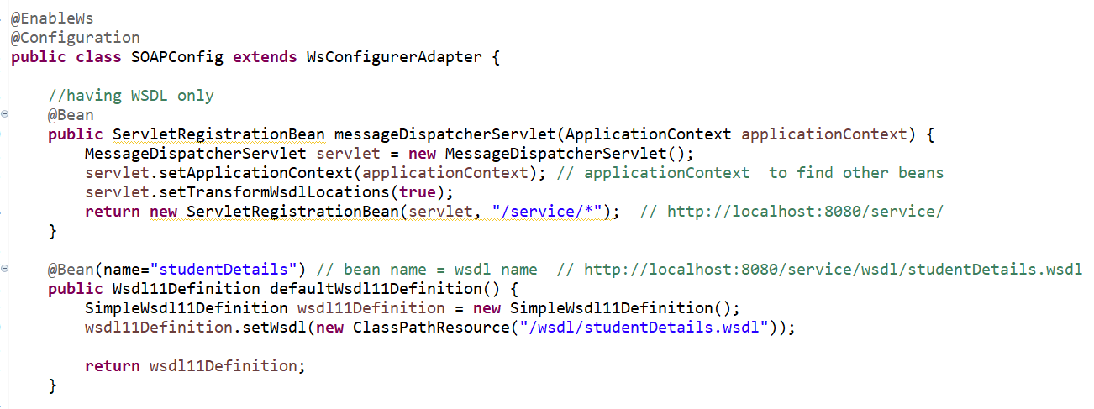

SpringBootApplication

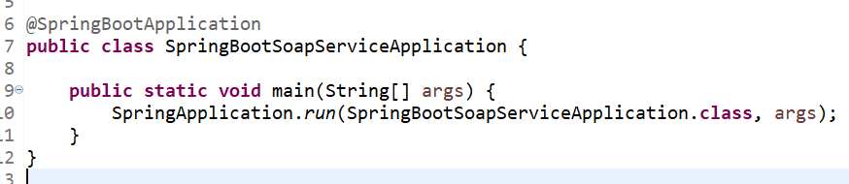

Endpoint

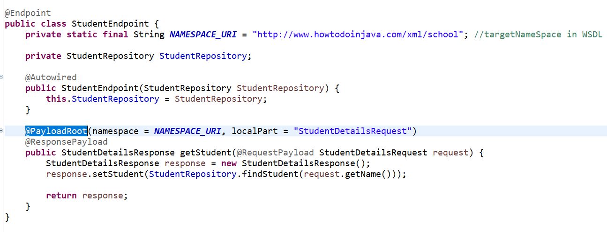

WSDL

<http://localhost:8080/service/wsdl/studentDetails.wsdl>

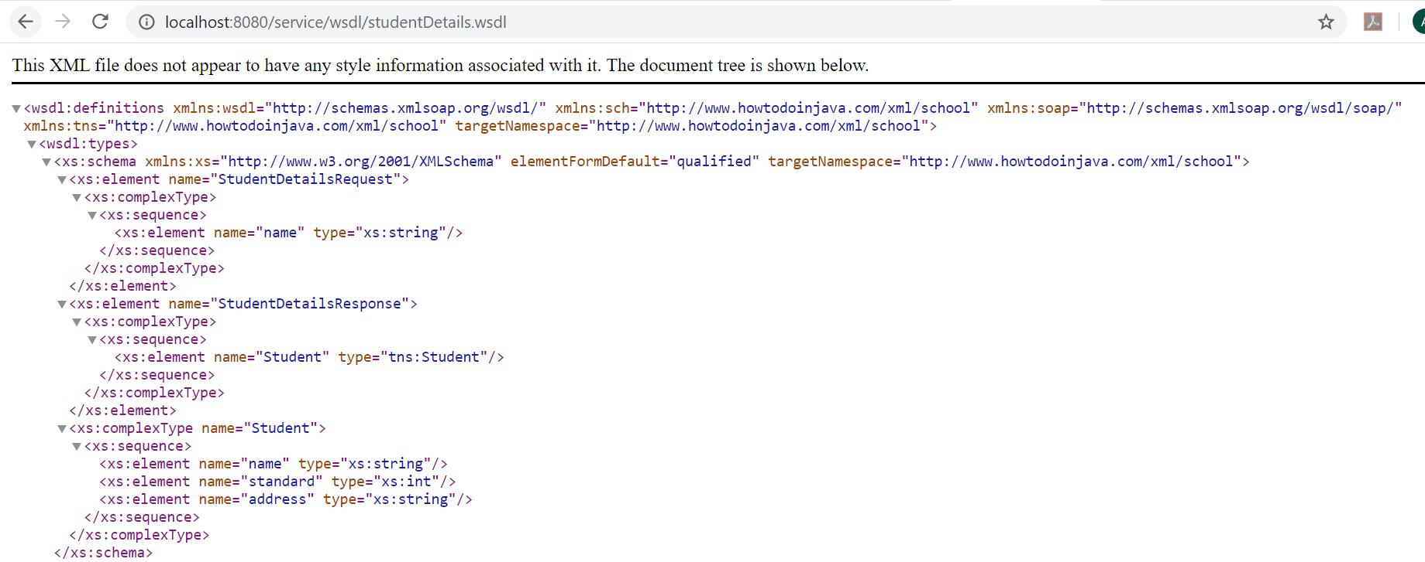

soap:address

This configuration also uses the WSDL location servlet transformation servlet.setTransformWsdlLocations( true ) internally. If we see the exported WSDL, the **soap:address** will have the localhost address. Similarly, if we instead visit the WSDL from the public facing IP address assigned to the deployed machine, we will see that address instead of localhost. So the endpoint URL is dynamic based on the deployment environment.

<soap:address location="http://localhost:8080/service/student-details"/>

soap:address : SOAP endpoint (in SOAPUI)

SOAP UI

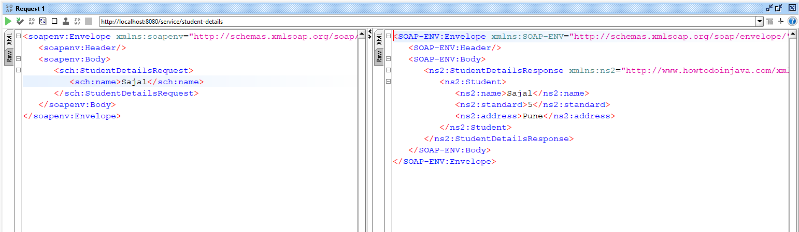

Help link

<https://howtodoinjava.com/spring-boot/spring-boot-soap-webservice-example/>

<https://howtodoinjava.com/spring-boot/spring-soap-client-webservicetemplate/>

SpringBoot + SOAPClient

pom.xml

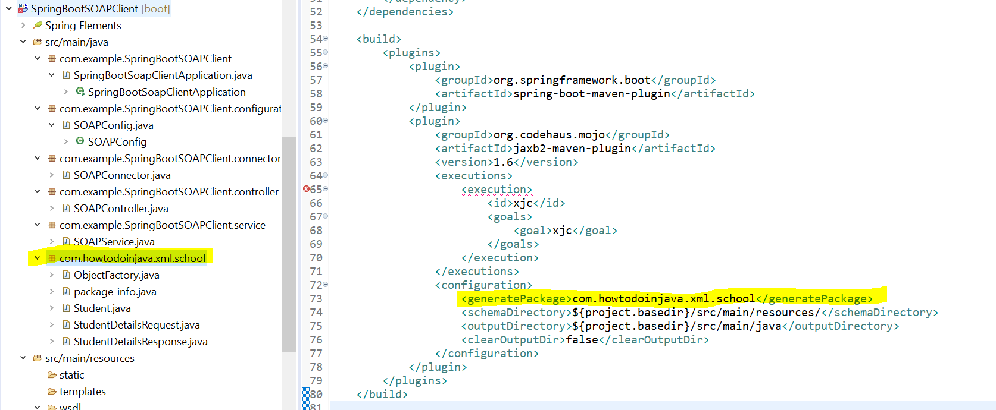

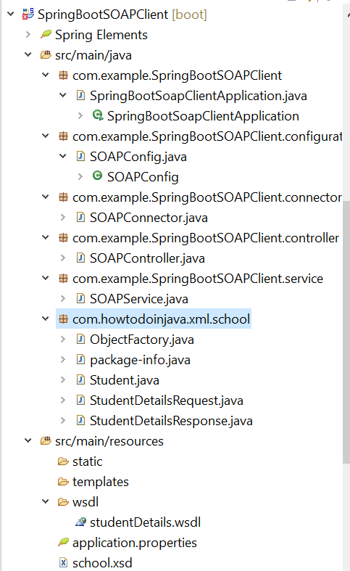

SOAPConnector ( extends WebServiceGatewaySupport )

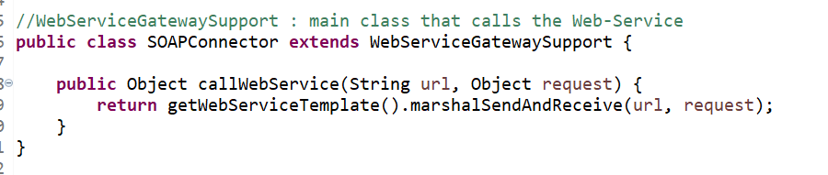

SOAPConfig

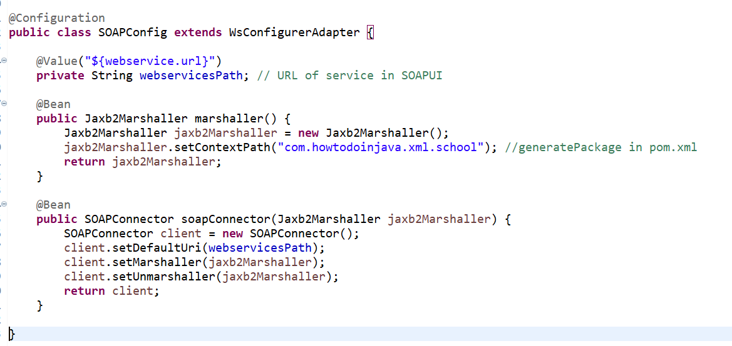

SOAPService

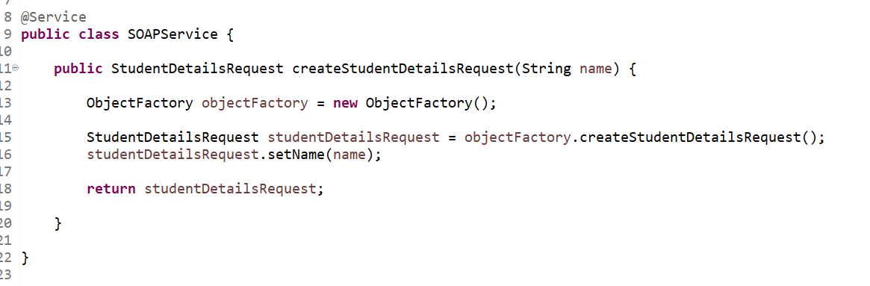

SOAPController

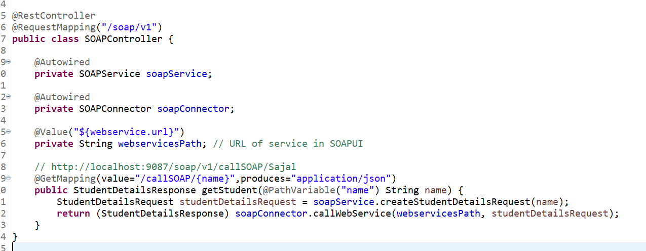

SpringBootApplication

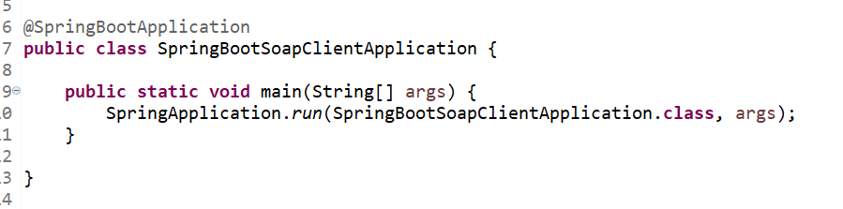

Run and Test

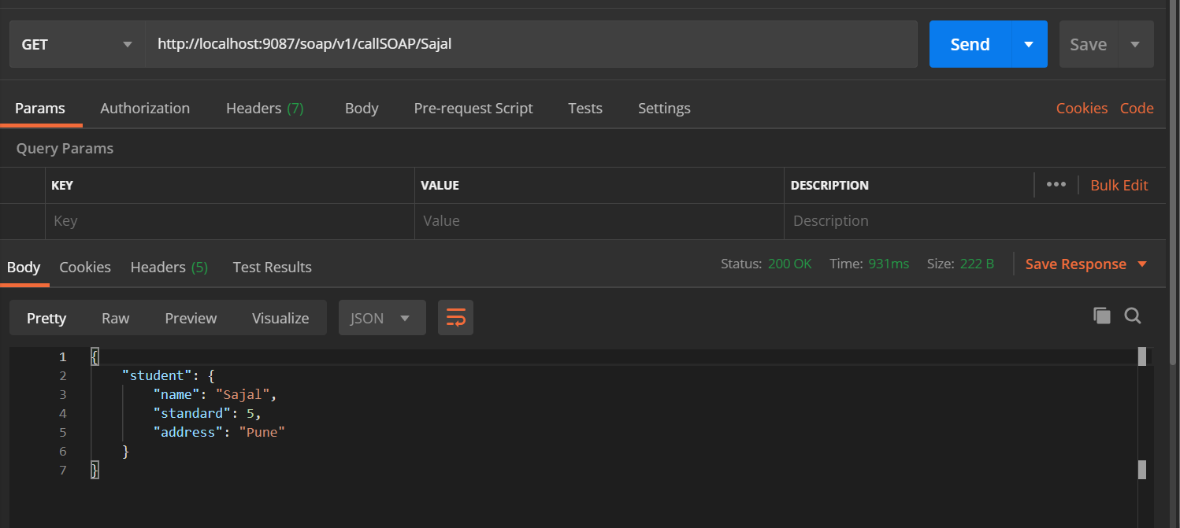

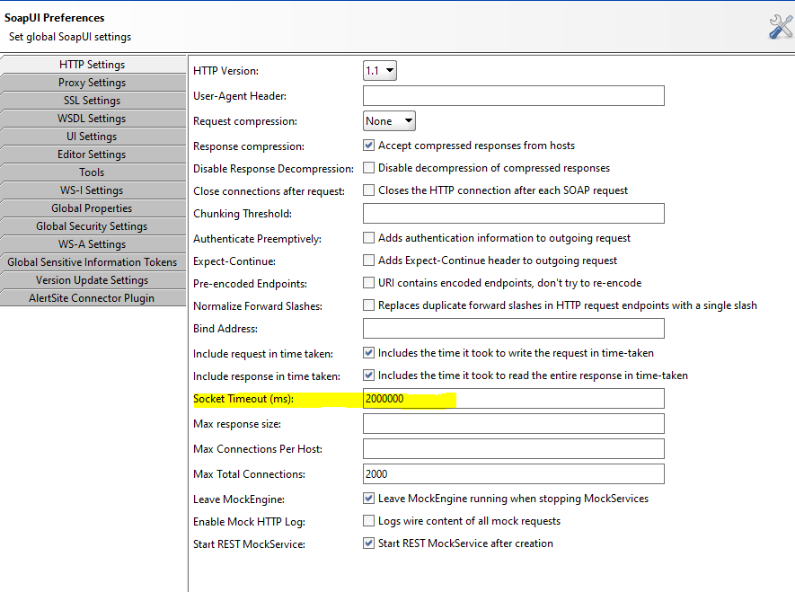

SOAP Invocation

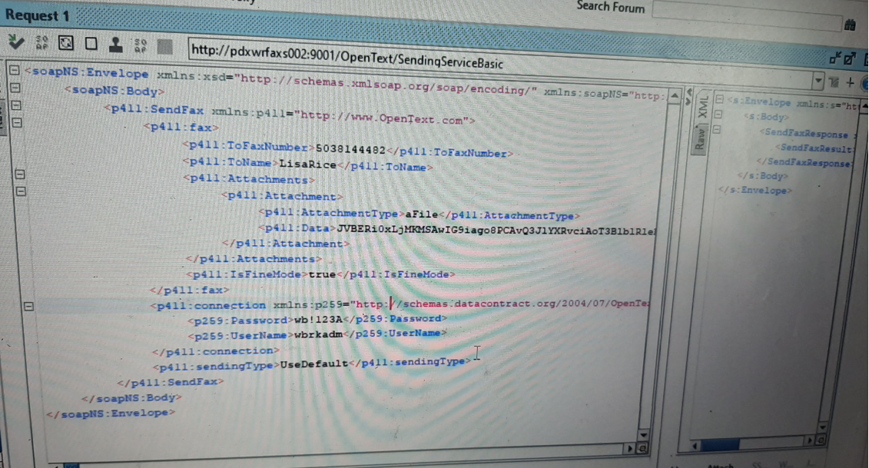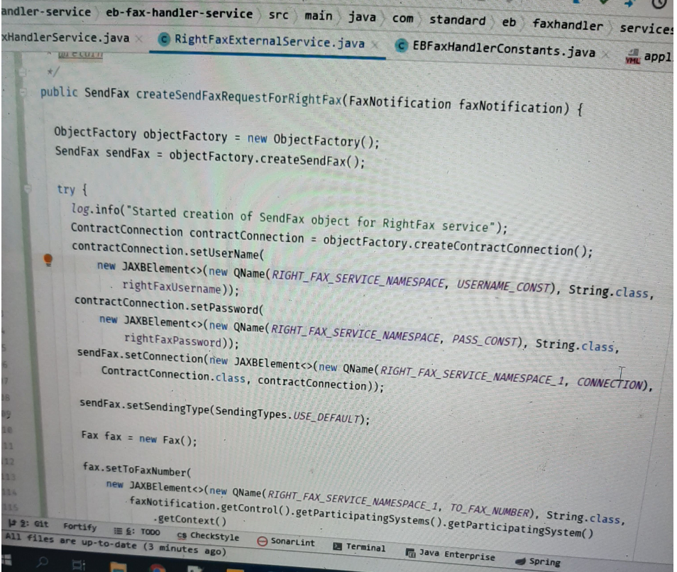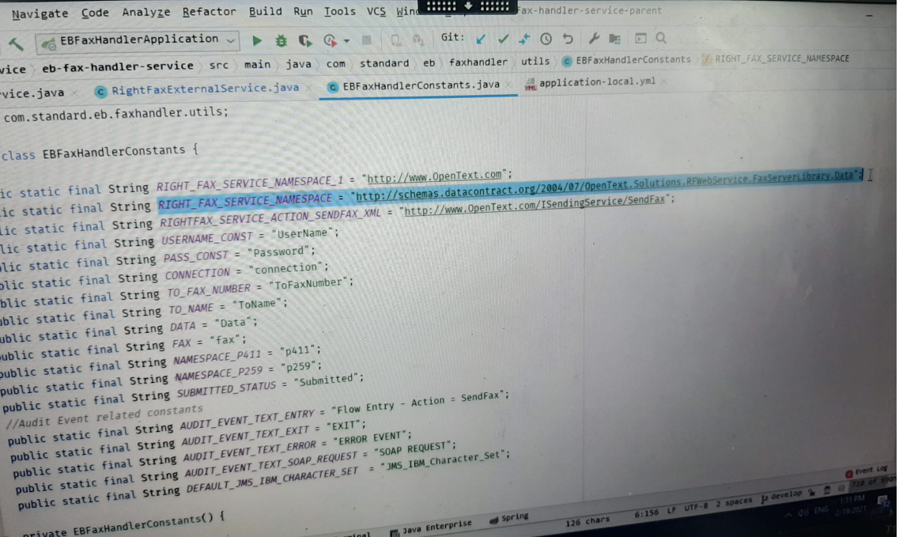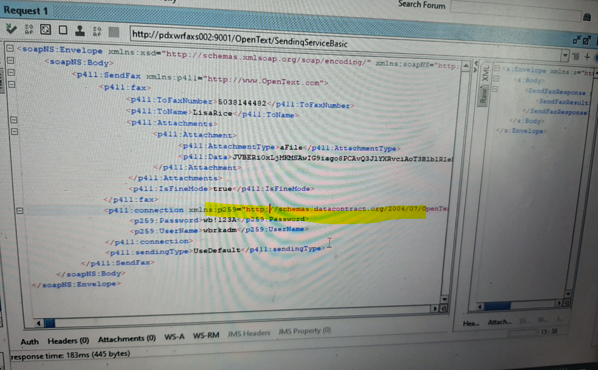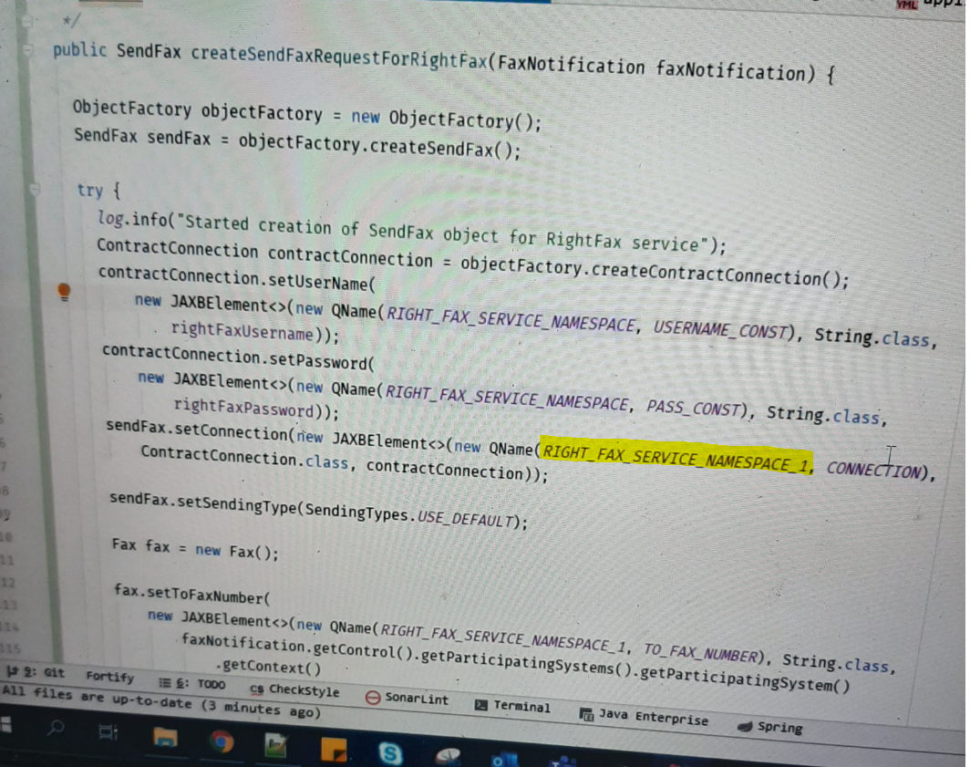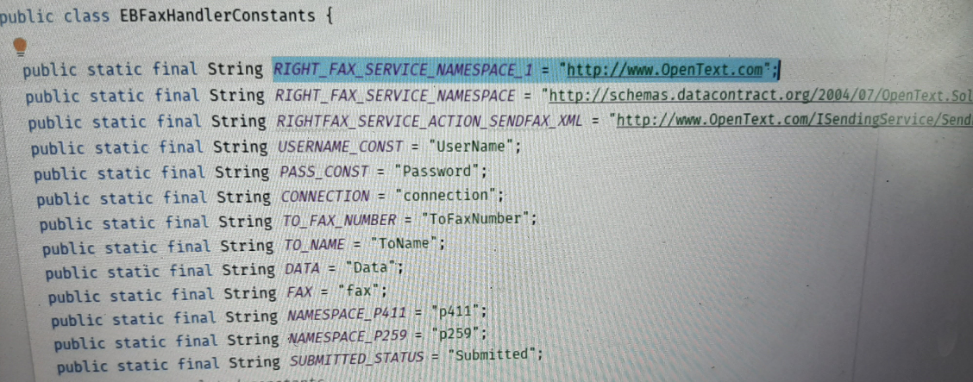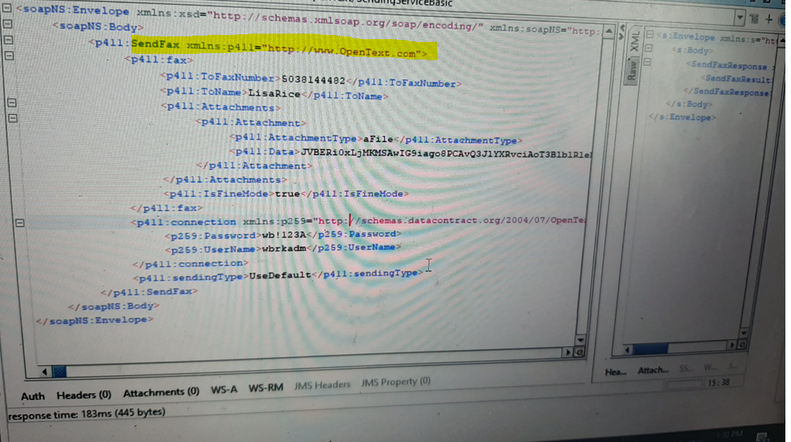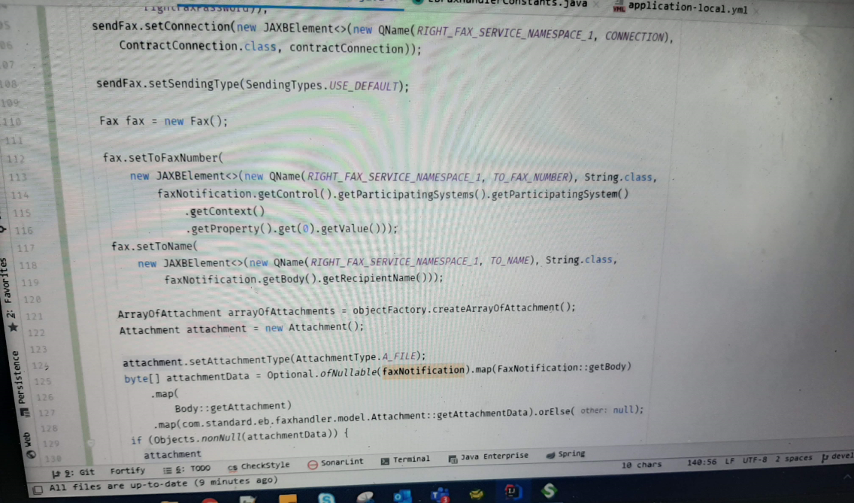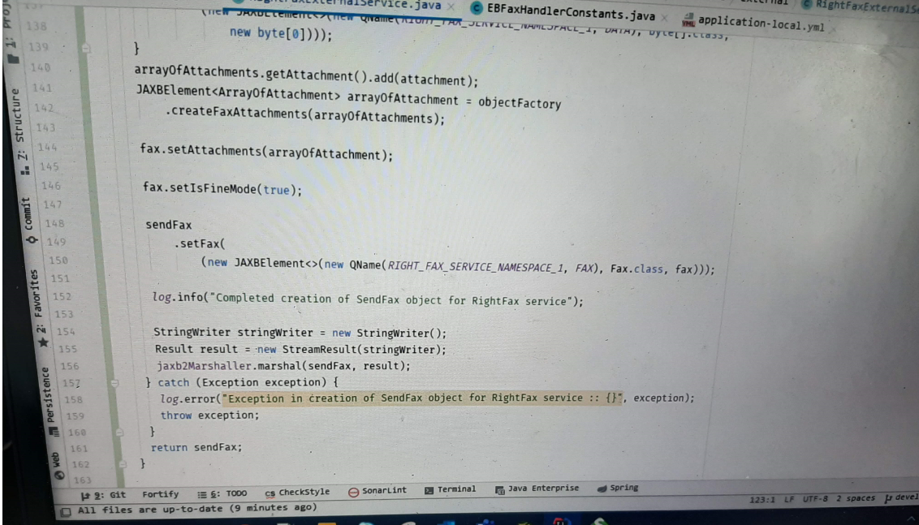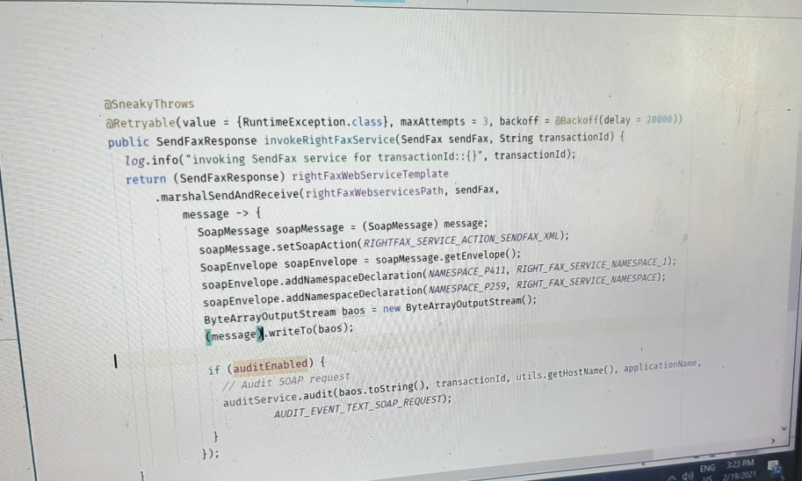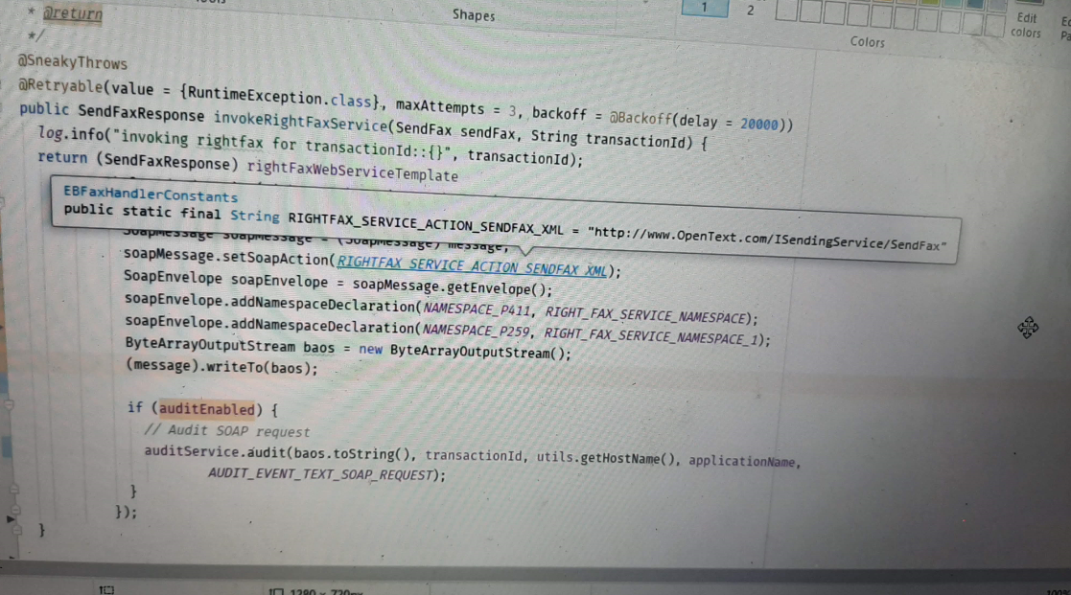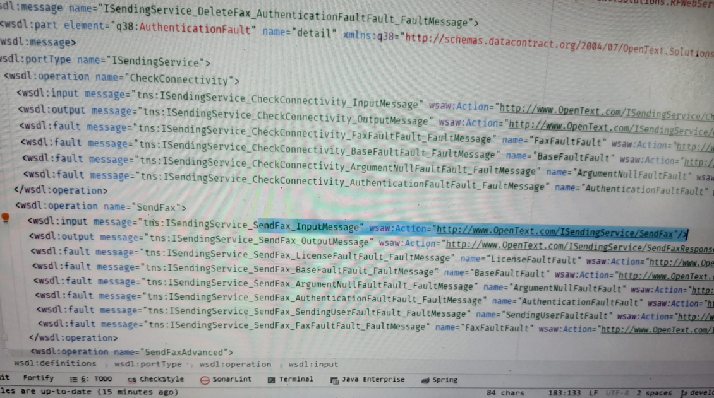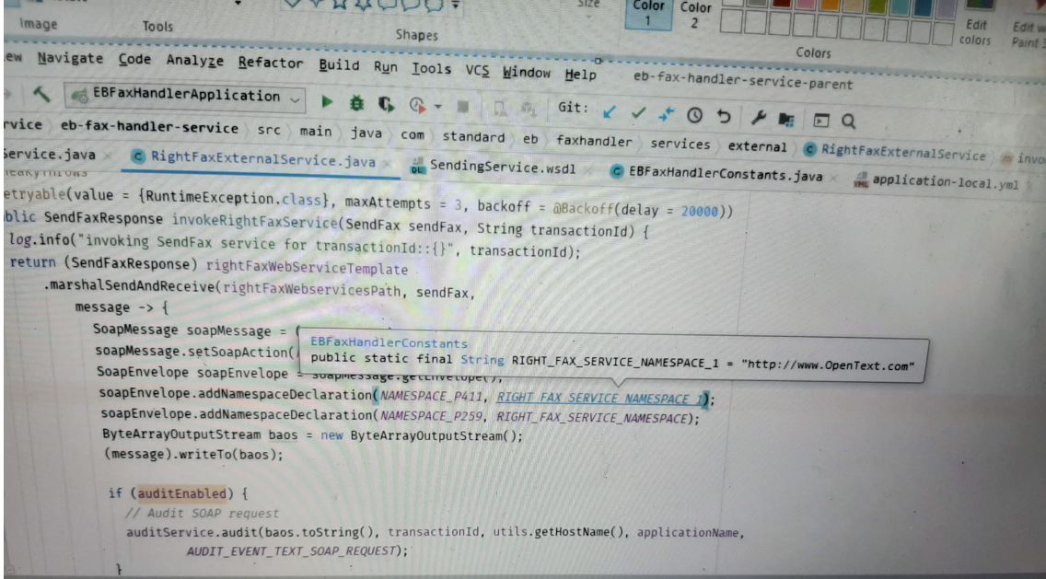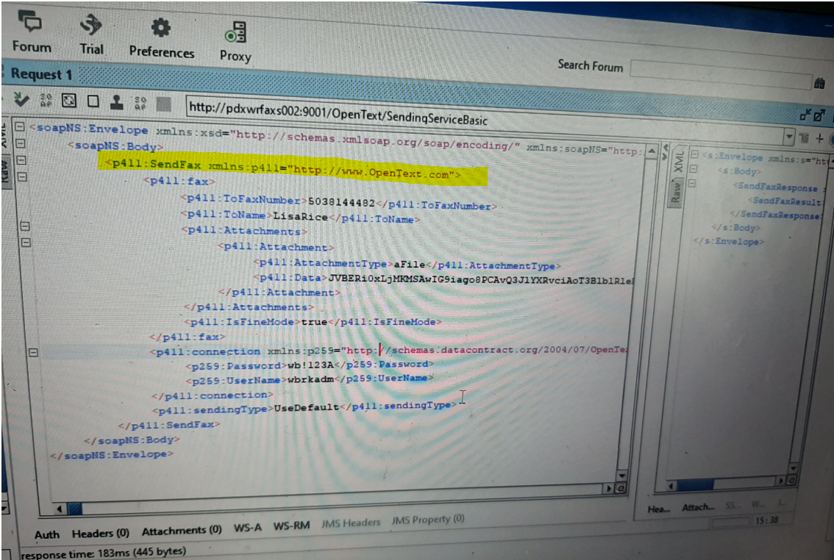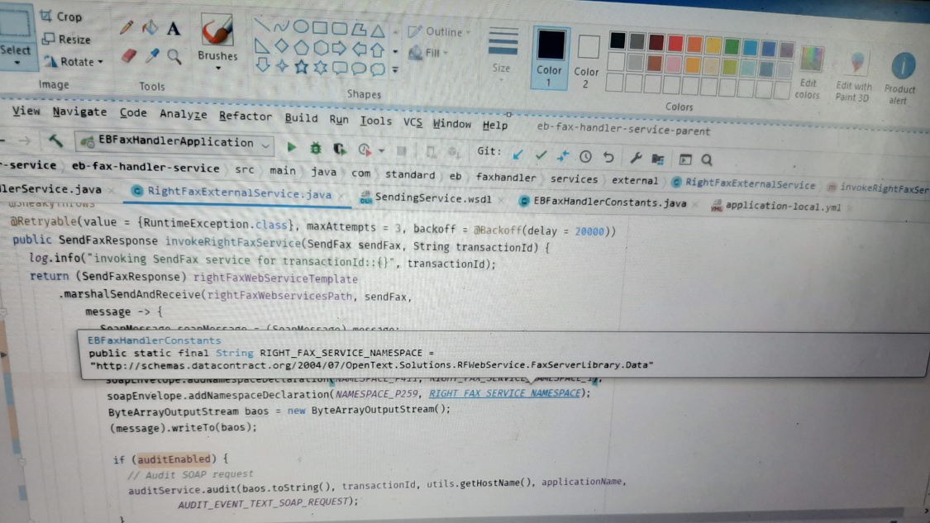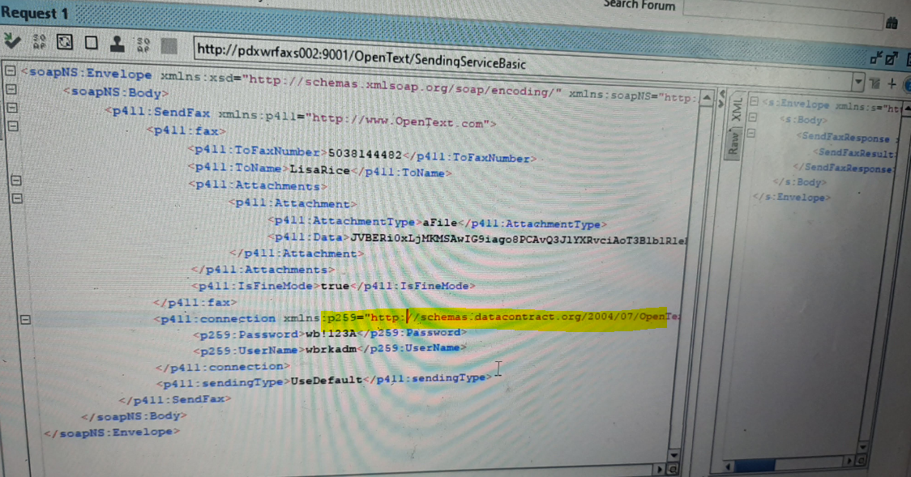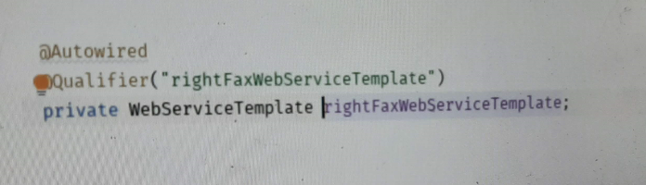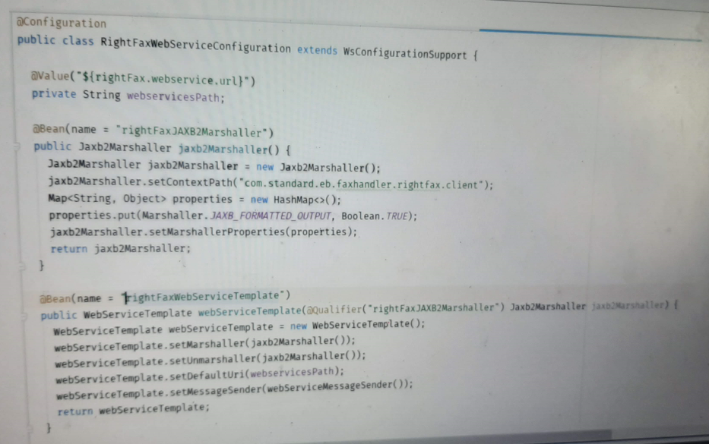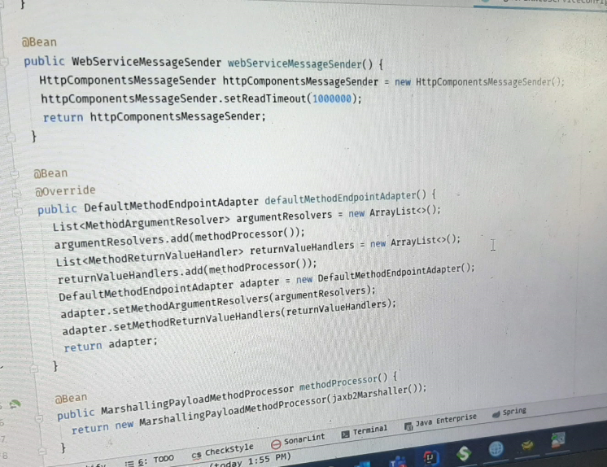

SOAP call with Authentication

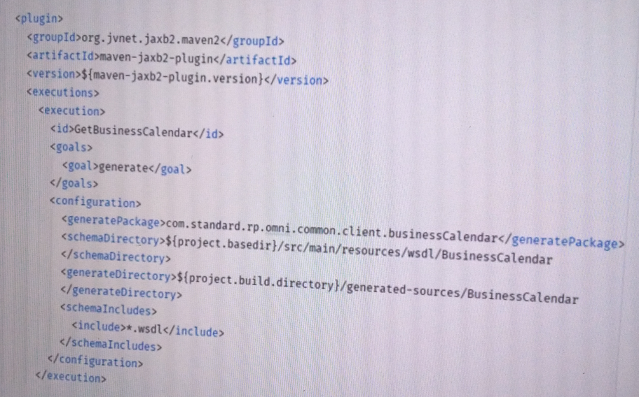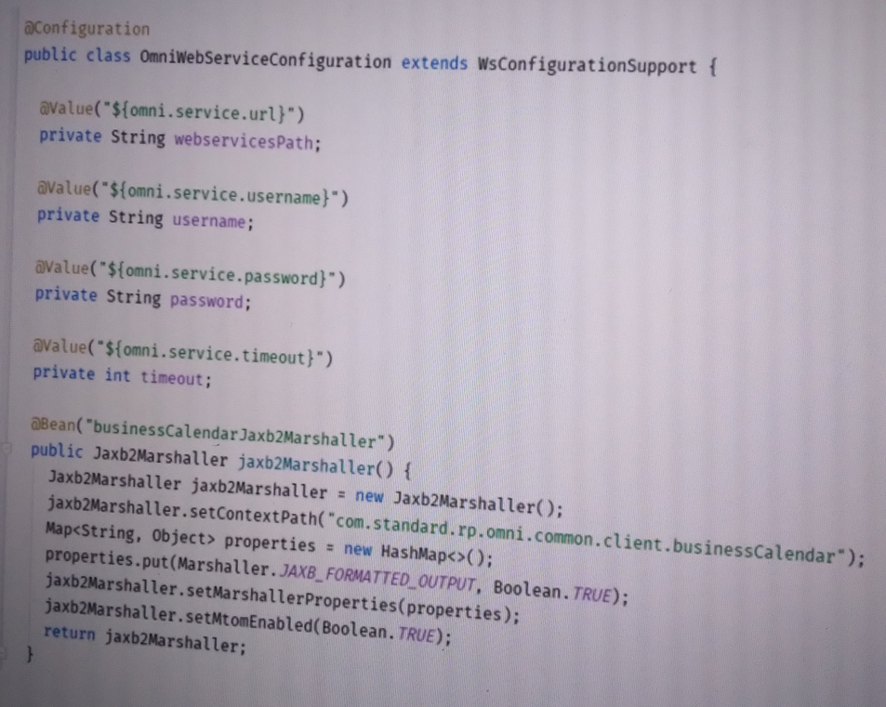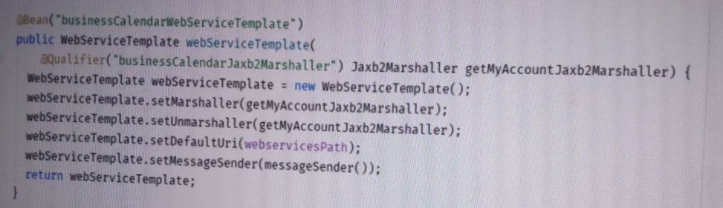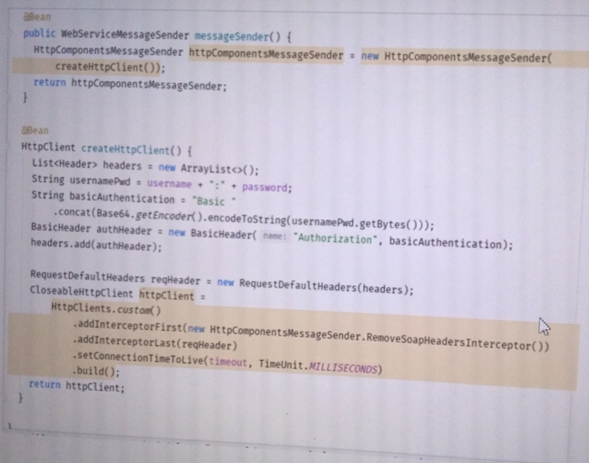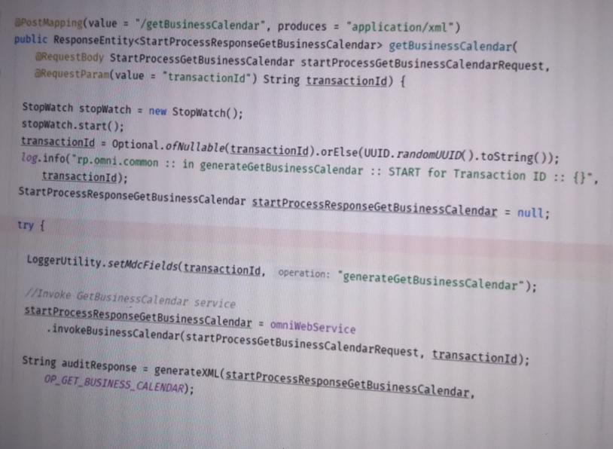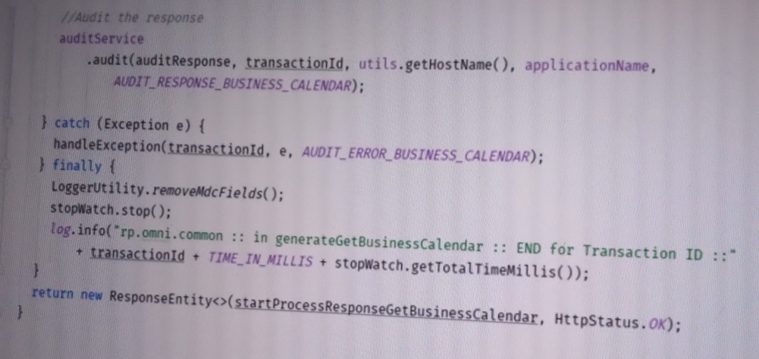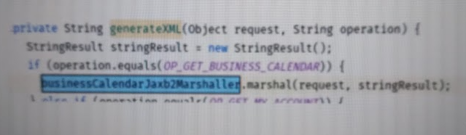

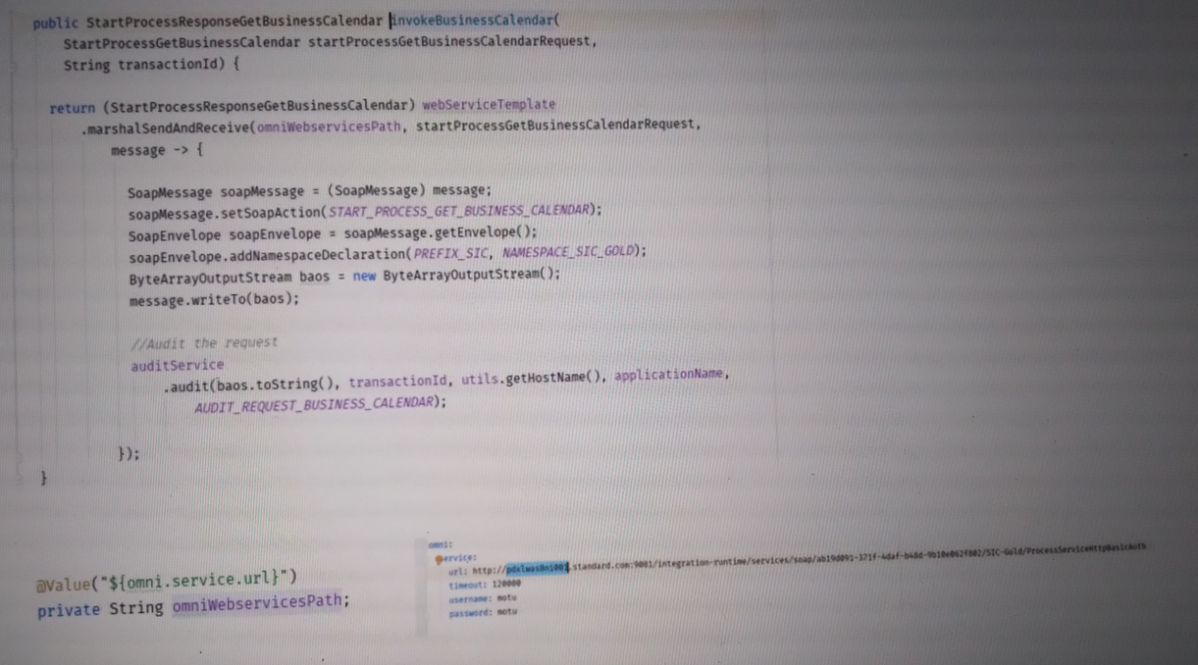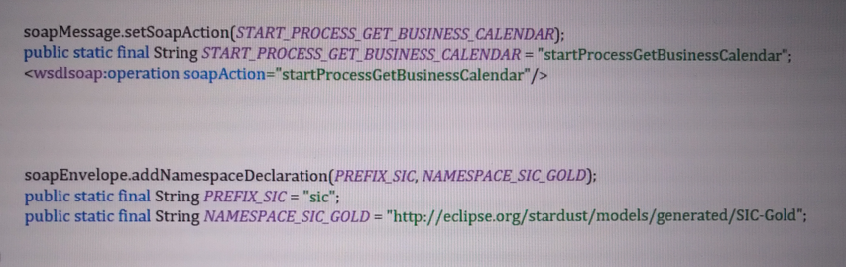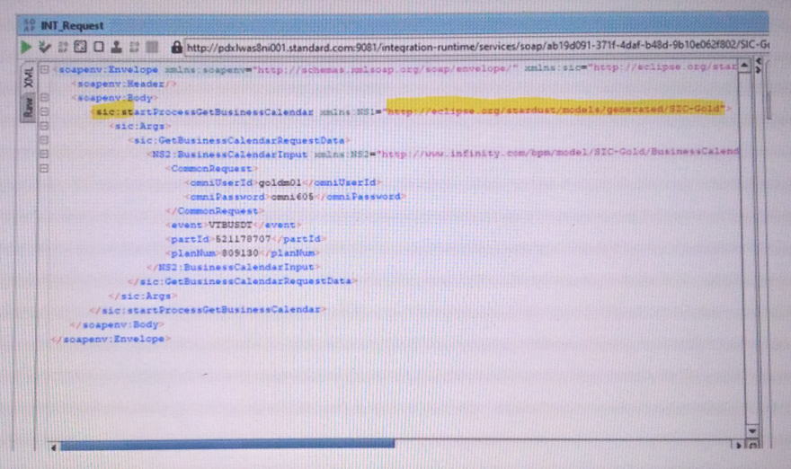

SOAP Certificate

1. Java Version: java-11-openjdk-11.0.7.10-1.windows.redhat.x86_64
2. Path Variable:

Place Java/bin at the top of the environment variable list

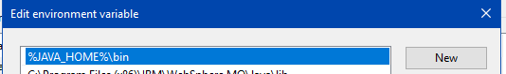

1. View existing Certificates

Certificates will be added in %JAVA_HOME%/lib/security/cacerts

%JAVA_HOME%/bin > keytool -list -keystore cacerts >C:\Softwares\keystore.txt

Password : changeit

1. Get Certificates

Generally 3 certificates are needed , the Server Certificate and the Root and Intermediary certificates. The Server certificate will be given by the Middleware team and Root and Intermediary certificates can be obtained by hitting the service url in browser.

1. Get Root and Intermediate Certificates by hitting the service URL in browser



Copy both the Root and Intermediary Certificates as below

Click on the padlock icon -> Certificate ->Certification Path -> Root Certificate -> View Certificate ->Details ->Copy to File

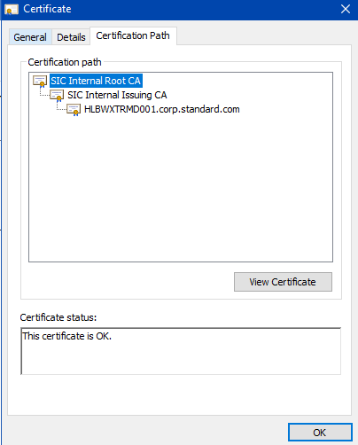

1. Add Certificate

Add Server Certificate

%JAVA_HOME%/bin >

keytool -import -keystore "C:\Softwares\java-11-openjdk-11.0.7.10-1.windows.redhat.x86_64\lib\security\cacerts" -storepass changeit -alias HLBWXTRMD001 -file "C:\Softwares\CERTIFICATES\HLBWXTRMD001corpstandardcom.crt"

Add Intermediate Certificate

keytool -import -keystore "C:\Softwares\java-11-openjdk-11.0.7.10-1.windows.redhat.x86_64\lib\security\cacerts" -storepass changeit -alias SICINTERMEDIATE -file "C:\Softwares\CERTIFICATES\SICINTERMEDIATE.cer"

Add Root Certificate

keytool -import -keystore "C:\Softwares\java-11-openjdk-11.0.7.10-1.windows.redhat.x86_64\lib\security\cacerts" -storepass changeit -alias SICROOT -file "C:\Softwares\CERTIFICATES\SICROOT.cer"

When prompted in cmd to change cacaerts : Y

Delete Certificate

keytool -delete -noprompt -trustcacerts -alias HLBWXTRMD001 -keystore "C:\Softwares\java-11-openjdk-11.0.7.10-1.windows.redhat.x86_64\lib\security\cacerts"

Check IDE

Check Installed JRE in IDE that it is pointing to JDK 11

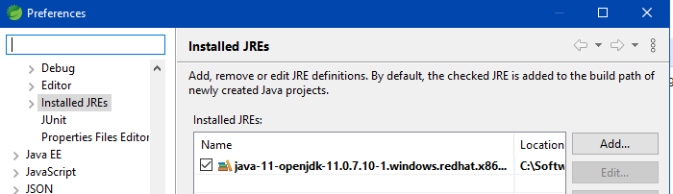

Project Build – check that JRE in Build is pointing to JDK11

If JDK8 is already installed , please put JDK11 as alternate JDK

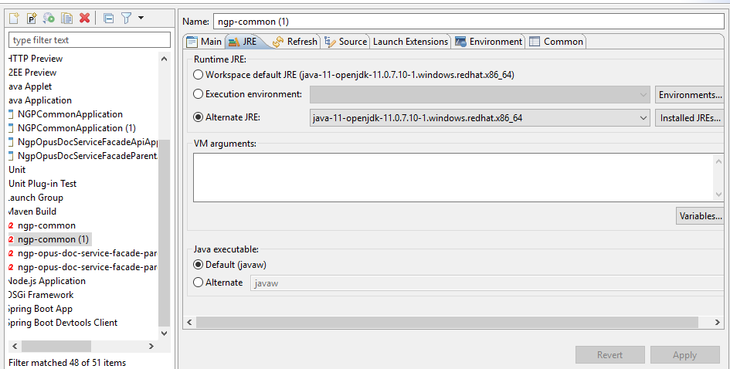

Project Run – check that JRE in Build is pointing to JDK11

